**Before you start, download these files from Dropbox**

1. The video needed

* Ex. 20230612_112630_standard_comp_to_training_D1_subj_1-2_and_1-1.1.fixed.mp4

1. The HDF5 file associated with the video

* Ex. 20230612_112630_standard_comp_to_training_D1_subj_1-2_and_1-1.1.fixed.1_subj.round_1.id_corrected.h5

1. Two csv files

* The contested frames dataframe
  + 20230612_112630_standard_comp_to_training_D1_subj_1-2_and_1-1.1contested_frames.csv
* The port entry dataframe
  + 20230612_112630_standard_comp_to_training_D1_subj_1-2_and_1-1.1.csv

1. Open sleap
2. Import file
   1. File -> Import -> SLEAP Analysis HDF5…

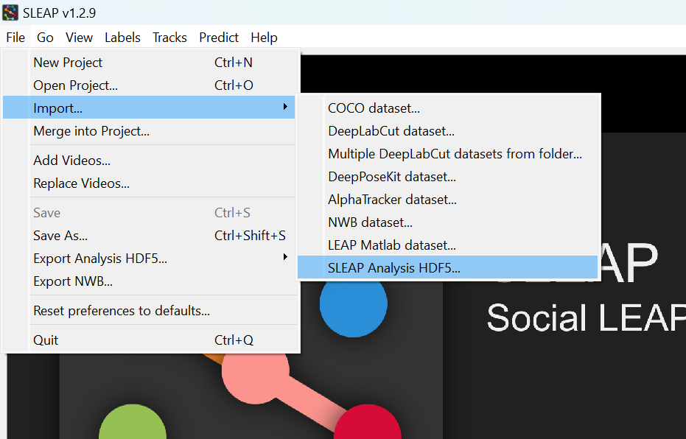

* 1. Select the HDF5 file associated with it. It will then prompt you to find the video associated with the file. Locate that as well and click “Import”

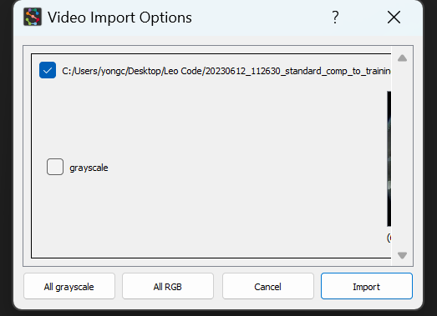

1. 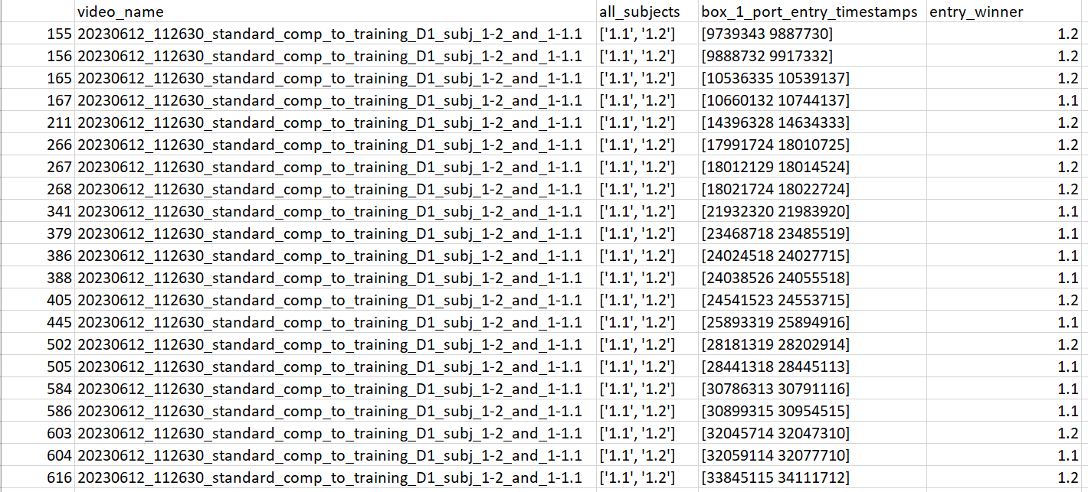Open up the contested frames dataframe. There should be 5 columns
2. 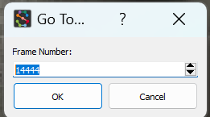Go to Sleap, click on the video and then do “Ctrl+J”. This should bring up a popup window that allows you to look at a specific frame.
3. For each row, type in the first frame number in “box_1_port_entry_timestamps”
   1. Ex. If I am looking at row 155, the Frame number I would pick is 9739343
4. Decide who got the reward associated with those frames and update the “entry_winner” cell associated with that trial.
5. When you are done, save the csv and close the file.
6. Open up the Jupyter Notebook titled “03_manual_curation_to_file.ipynb”. The only things that need to be changed are in the first cell
   1. full_csv_file_path
   2. contested_csv_file_path
   3. full_csv_combined_save_file_path
   4. full_csv_combined_save_name

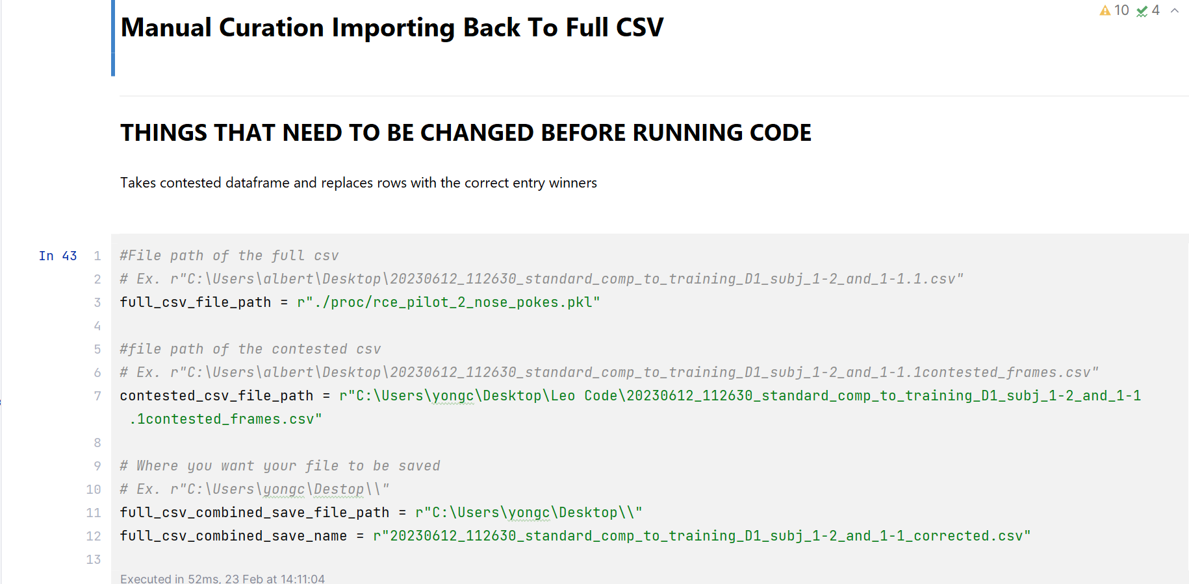

1. Once those are changed, select run all. Then scroll down and verify that your entry winners are what you inputted manually

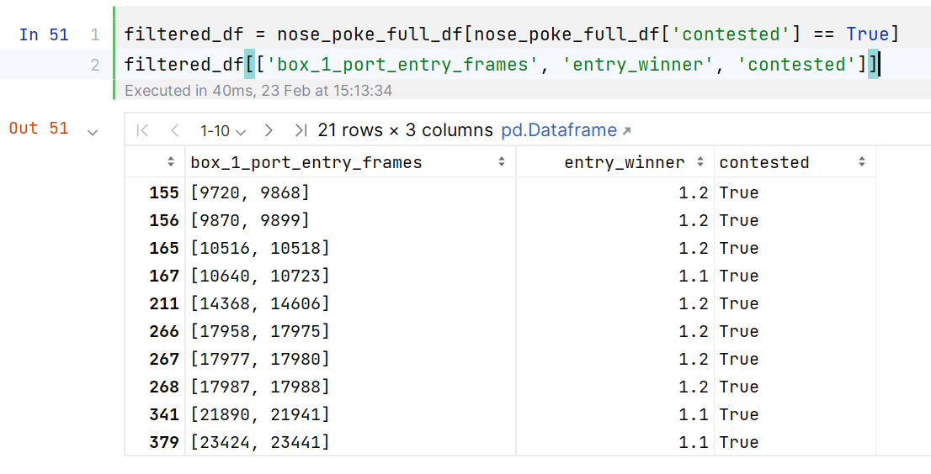

1. If everything checks out, upload the new corrected csv back to Dropbox.